TPA: Cloth Modeling on Human Body

Realistic modeling and high performance rendering of clothing is a challenging problem. Dynamic cloth simulation software is used for virtual fashion catalogs, as well as for dressing 3D characters for video games, animation movies etc.
Objective:
To develop a cloth simulator using cloth physics, Verlet integration and iterative constraint satisfaction. The simulation of cloth is the simulation of particles with mass and interconnections, called constraints or springs, between the fibers in the cloth. Particles move around in space due to forces that affect them – e.g. wind, gravity, or springs between particles.
Physics:
- Force can be “translated” into acceleration through Newtons second law: acceleration = force/mass
- Acceleration can be “translated” into position by numerical integration – since position d(t) twice differentiated is equal to acceleration.
Input:
-Wireframe mesh of a human body.
-Wireframe mesh of clothes.
-Motion dynamics of the supporting object may also be involved (Optional).
Output:
Animation & stable position of cloth draped on Human mesh.
Process to simulate:
- Add collision with human mesh. Drape the Tshirt on the human mesh in different positions and enable realistic cloth deformation, wrinkles and movement.

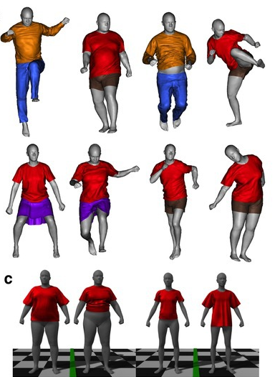
Assumption:
-Cloth simulation will be implemented using C++ and openGL.
References:
- D. Baraff, A. Witkin: "Large Steps in Cloth Simulation", SIGGRAPH 1998.
- Kwang-Jin Choi, Hyeong-Seok Ko: "Stable but Responsive Cloth", SIGGRAPH 2002.
- T. Jakobsen: "Advanced Character Physics", Gamasutra, January 21 2003.
- H. Enqvist: "The Secrets Of Cloth Simulation In Alan Wake", Gamasutra, April 29, 2010.
- X. Provot: "Deformation constraints in a mass-spring model to describe rigid cloth behavior", Graphics Interface 1995.
- Gavin Hayler, Shaun Bangay and Adele Lobb: “Implicit and Explicit Methods of Cloth Simulation”
- Guan, P., Reiss, L., Hirshberg, D. A., Weiss, A., & Black, M. J. (2012). DRAPE: DRessing Any PErson. ACM Trans. Graph., 31(4), 35-1.
Code:
- Cloth Simulation Coding tutorial(Verlet integration) - http://cg.alexandra.dk/?p=147
- Cloth hanging by 2 points, blowing in the wind, gravity and collision with a ball.
- OpenCloth - https://github.com/mmmovania/opencloth/blob/master/README.md
- OpenGL based cloth simulation code base.
- Implements all of the existing cloth simulation algorithms
- Helps beginners and researchers alike to implement the basic algorithms for cloth simulation using OpenGL API.
Currently. this project contains complete implementations of (in alphabetical order)
- Co-Rotated Linear FEM
- Explicit Euler integration
- Explicit Euler integration with texture mapping and lighting
- Explicit Euler integration with wind
- Implicit Explicit (IMEX) method
- Implicit integration (Baraff & Witkin's model)
- Implicit Euler integration
- Meshless FEM
- Position based dynamics
- Semi-Implicit integration (Symplectic Euler)
- Verlet integration
- Verlet integration on CUDA, GLSL (using GPGPU technique) and OpenCL
- WebGL port of Explicit Euler Integration
- Cloth Demo Code: http://www.nickcrook.ca/
- Cloth falling over a ball
- Cloth Simulation: https://github.com/ArturoNereu/ClothSim
- Cloth falling over a ball with many configurable parameters in an UI using GLUI
- Wireframe meshes (Meshes.zip):
- Human Mesh
- Cloth Mesh

