**Image Stitching**

Computer Vision (CS6350)

**TPA - \***

1. **Problem Statement**

Image Stitching is a process of composing multiple images with narrow but overlapping fields of view to create a larger image with a wider field of view. Image stitching has several applications like panorama creation, robot target recognition etc.

1. **Input**

Multiple partially overlapped images

1. **Output**

One bigger stitched image

1. **Examples**

**Example 1**

**Input Image:**

** **

**Output Image:**



**Example 2**

**Input Image:**

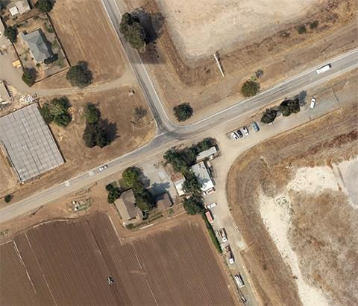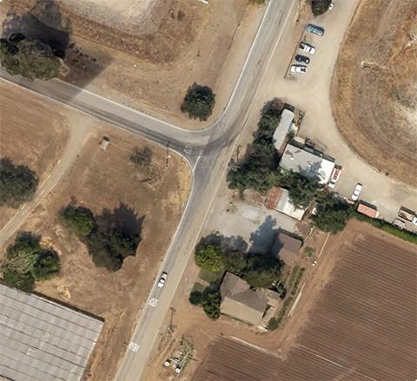

**Output Image:**

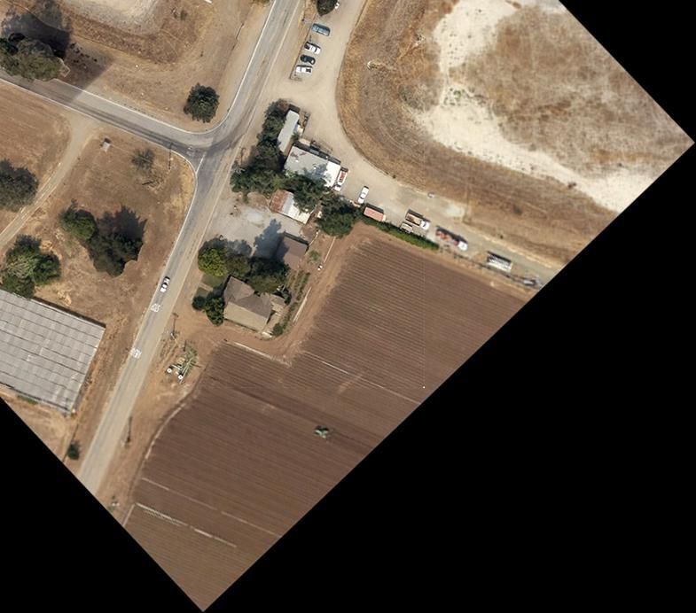

**Example 3**

**Input Image:**

**  **

**Output Image:**

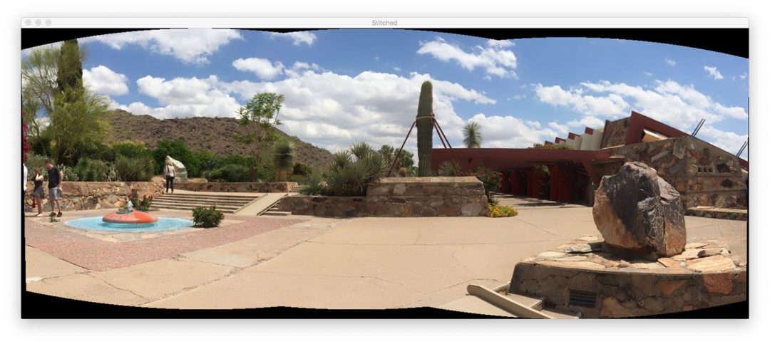

1. **Dataset**

* The **HPatches** is a recent dataset for local patch descriptor evaluation that consists of 116 sequences of 6 images with known homography. The dataset is split into two parts: viewpoint - 59 sequences with significant viewpoint change and illumination - 57 sequences with significant illumination change, both natural and artificial.
* **UDIS-D** is a large image dataset for image stitching or image registration. It contains different overlap rates, varying degrees of parallax, and variable scenes such as indoor, outdoor, night, dark, snow, and zooming.
* **CROSS** is a novel omnidirectional image dataset containing stitched images as well as dual-fisheye images captured from standard quarters of 0◦, 90◦ , 180◦ and 270◦. In this manner, when evaluating the quality of an image stitched from a pair of fisheye images (e.g., 0◦ and 180◦), the other pair of fisheye images (e.g., 90◦ and 270◦) can be used as the cross-reference to provide ground-truth observations of the stitching regions.
* **PhotoSynth** (PS) dataset for patch matching consists of a total of 30 scenes with 25 scenes for training and 5 scenes for validation. The different image pairs are captured in different illumination conditions, at different scales and with different viewpoints.

**References**

1. Nie, L., Lin, C., Liao, K., Liu, S. and Zhao, Y., 2021. Depth-Aware Multi-Grid Deep Homography Estimation with Contextual Correlation. *arXiv preprint arXiv:2107.02524*.
2. Chen, Y.S. and Chuang, Y.Y., 2016, October. Natural image stitching with the global similarity prior. In *European conference on computer vision* (pp. 186-201). Springer, Cham.
3. Jia, Q., Li, Z., Fan, X., Zhao, H., Teng, S., Ye, X. and Latecki, L.J., 2021. Leveraging Line-Point Consistence To Preserve Structures for Wide Parallax Image Stitching. In *Proceedings of the IEEE/CVF Conference on Computer Vision and Pattern Recognition* (pp. 12186-12195).
4. Nie, L., Lin, C., Liao, K., Liu, S. and Zhao, Y., 2021. Unsupervised Deep Image Stitching: Reconstructing Stitched Features to Images. *IEEE Transactions on Image Processing*.

#### Liao, Tianli, and Nan Li. "Natural Image Stitching Using Depth Maps." *arXiv preprint arXiv:2202.06276* (2022).

1. Nie, Lang, et al. "Unsupervised deep image stitching: Reconstructing stitched features to images." *IEEE Transactions on Image Processing* 30 (2021): 6184-6197.
2. Li, Jiaxue, and Yicong Zhou. "Automatic Color Image Stitching Using Quaternion Rank-1 Alignment." *Proceedings of the IEEE/CVF Conference on Computer Vision and Pattern Recognition*. 2022.
3. Adel, E., Elmogy, M. and Elbakry, H., 2014. Image stitching based on feature extraction techniques: a survey. *International Journal of Computer Applications*, *99*(6), pp.1-8.

Aug, 2022