**Domain Adaptation in Object Detection using Weakly-supervised/unsupervised Data in Target Domain**

Computer Vision (CS6350)

**TPA-1**

1. **Problem Statement**

This problem introduces the task of domain adaptation in object detection using weakly-

supervised or unsupervised data in the target domain. Given data from two different domains, the source domain and the target domain, the goal is to generalize well on the

target domain data which is weakly labeled or completely unlabelled. The classes to be

detected in the target domain are all or a subset of those in the source domain.

1. **Input**

* Images from source and target domain.
* Annotations for data in the source domain.
* Annotations for data in the target domain (in case of weakly labeled data only).

1. **Expected Output**

* 2D Bounding boxes for objects detected in the target domain.
* Quantitative performance evaluated on the target domain dataset using mAP metric.
* Qualitative Results on the target domain data.

A sample input output is shown below: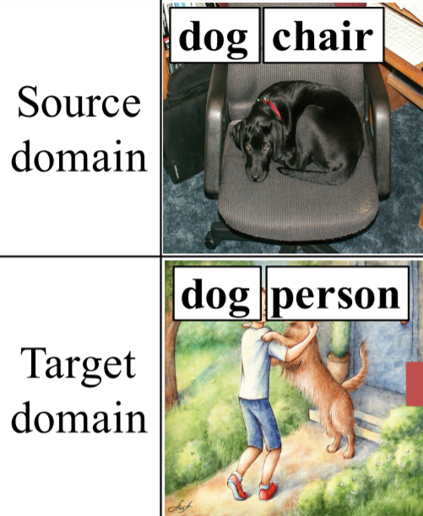

1. **Datasets**

* Cityscapes & Foggy Cityscapes
* PASCAL VOC & Clipart 1K

1. **References**

1. Ren, Zhongzheng, et al. "Instance-Aware, Context-Focused, and Memory-Efficient

Weakly Supervised Object Detection." Proceedings of the IEEE/CVF Conference on

Computer Vision and Pattern Recognition. 2020.

2. Hsu, Han-Kai, et al. "Progressive domain adaptation for object detection." The IEEE

Winter Conference on Applications of Computer Vision. 2020.

3. Saito, Kuniaki, et al. "Strong-weak distribution alignment for adaptive object detection." Proceedings of the IEEE Conference on Computer Vision and Pattern Recognition. 2019.

4. Inoue, Naoto, et al. "Cross-domain weakly-supervised object detection through

progressive domain adaptation." Proceedings of the IEEE conference on computer

vision and pattern recognition. 2018.

5. Chen, Yuhua, et al. "Domain adaptive faster r-cnn for object detection in the wild."

Proceed-ings of the IEEE conference on computer vision and pattern recognition.

2018.

August 2022