**Image to Image transformation (few samples)**

**using VAE, GANs etc**

Computer Vision (CS6350)

**TPA - 10**

1. **Problem Statement**

Models trained on high-quality (DSLR) images may underperform when tested on low-quality (USB-cam) images.

One way to tackle this problem is to train an image-to-image translation (VAE or GAN based) model for domain adaptation that can transform the quality of the input image. This model can then be used to transform test time images such that they are of the same quality as train time images.

Concretely, the goal of this TPA is to train an image-to-image translation model that can translate high-quality (DSLR) images into (USB-cam) low-quality images having the same dimensions (height and width) and/or model that can translate low-quality images into high-quality images.

1. **Input**

Single RGB image (DSLR or USB-cam).

1. **Output**

Quality (DSLR-to-USB and/or USB-to-DSLR) translated RGB image having the same dimensions as the input image (height and width).

1. **Datasets**
2. **In-house VPLab DA dataset (Mail TAs and sir to get access):**

1500 pairs of DSLR and USB-cam images.

DSLR image and the corresponding USB-cam image may or may not have the exact same view field.

1. [DPED Dataset](http://people.ee.ethz.ch/~ihnatova/#dataset) [6]

Note: It is mandatory to use both these datasets for the TPA.

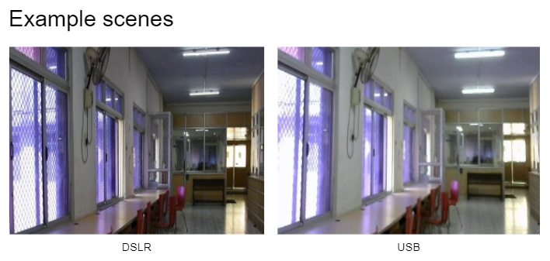

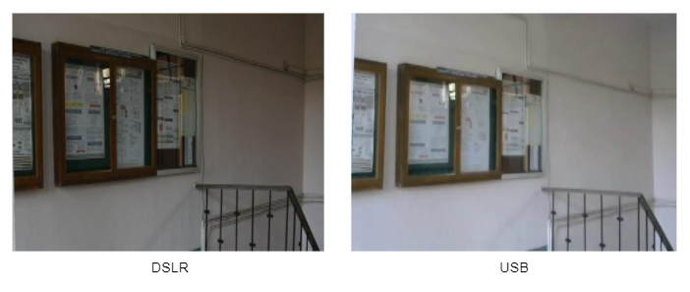

1. **References**

[1] Du, Wenchao, Hu Chen, and Hongyu Yang. "Learning invariant representation for unsupervised image restoration." Proceedings of the IEEE/CVF Conference on Computer Vision and Pattern Recognition. 2020.

[2] Liu, Ming-Yu, Thomas Breuel, and Jan Kautz. "Unsupervised image-to-image translation networks." arXiv preprint arXiv:1703.00848 (2017).

[3] Zhu, Jun-Yan, et al. "Unpaired image-to-image translation using cycle-consistent adversarial networks." Proceedings of the IEEE international conference on computer vision. 2017.

[4] Wan, Ziyu, et al. "Bringing old photos back to life." Proceedings of the IEEE/CVF Conference on Computer Vision and Pattern Recognition. 2020.

[5] Huang, Huaibo, et al. "Introvae: Introspective variational autoencoders for photographic image synthesis." arXiv preprint arXiv:1807.06358 (2018).

[6] "Ignatov, Andrey, Nikolay Kobyshev, Radu Timofte, Kenneth Vanhoey, and Luc Van Gool. "Dslr-quality photos on mobile devices with deep convolutional networks." In Proceedings of the IEEE International Conference on Computer Vision, pp. 3277-3285. 2017".

Aug, 2022