**3D Semantic Scene reconstruction and depth map / wireframe / Point-Cloud from single RGB panorama scene (or Two views)**

Computer Vision (CS6350)

**TPA - 12**

1. **Problem Statement**

The purpose of this project is to develop algorithms capable of three-dimensional semantic Scene Reconstruction from a single panorama scene (constructed from a pair of frames) and its corresponding semantic segmentation mask. The basic steps of a typical 3D reconstruction process are: predicting the depth map (disparity map), estimating depth of (visually) salient landmarks, tessellation to create a wireframe representation and finally rendering (preferably use OpenGL) with semantic colors of the various classes in the segmentation mask of the panorama. Depending on the model used, alternative methods can be adopted.

1. **Input**

• A panorama scene (or a pair of stereo frames)

• Segmentation mask of the panorama (or separately for both frames)

See examples in the following:

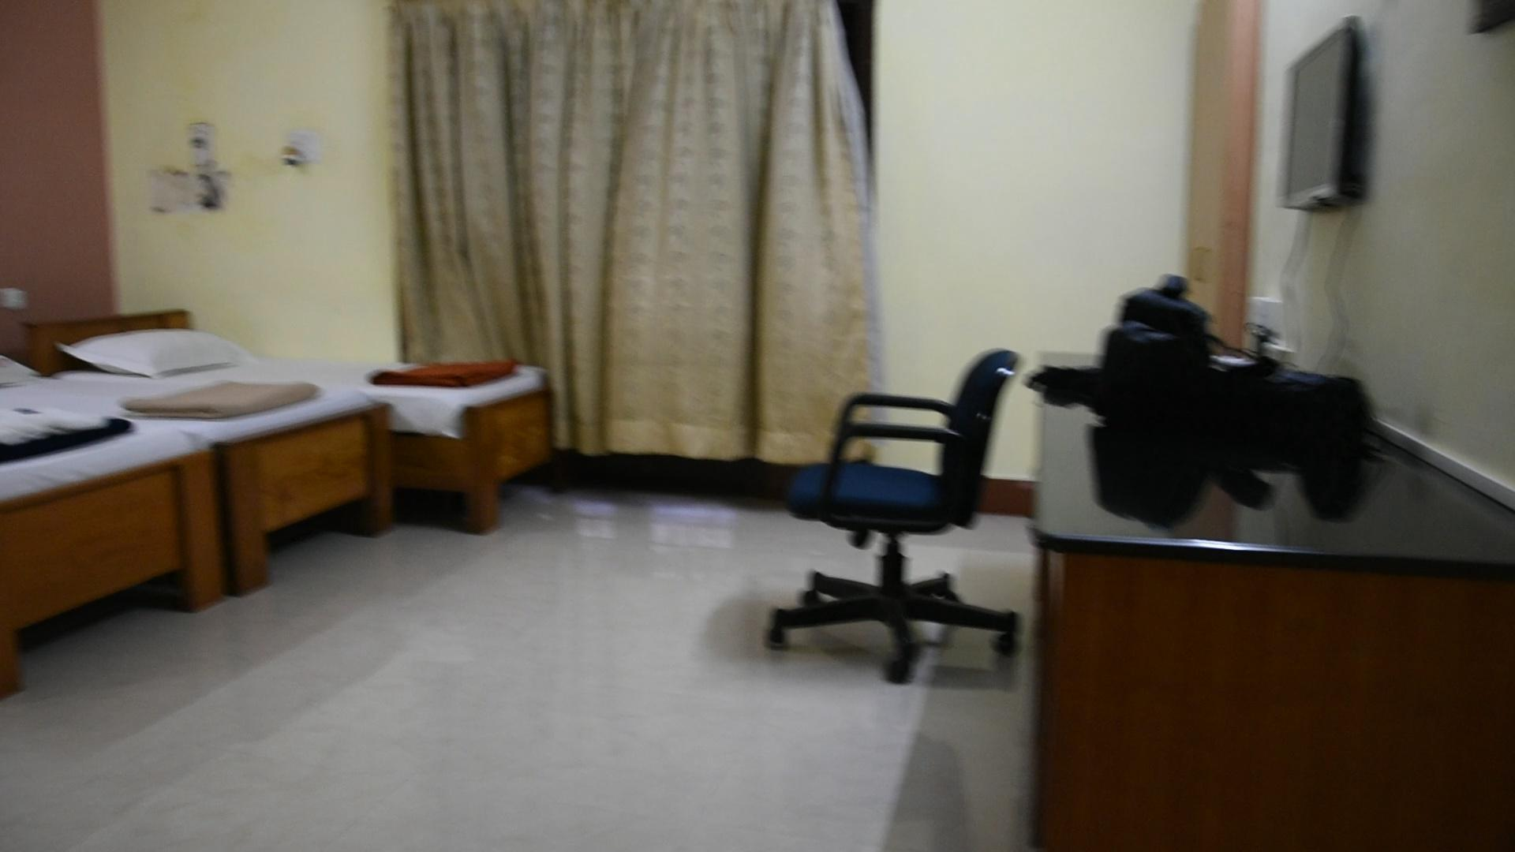

**Input scene (not Panorama)**

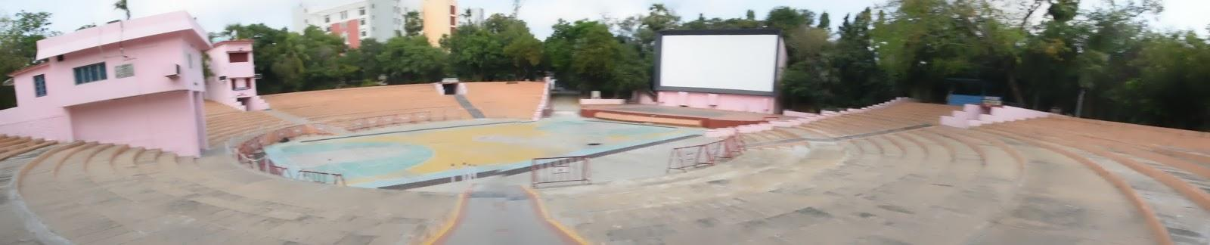

**Input Scene (Panorama)**

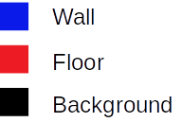

**Segmentation mask**

**3. Datasets**

• KITTI Dataset

link -<http://www.cvlibs.net/datasets/kitti/eval_object.php?obj_benchmark=3d>

• NYU Depth v2 Dataset link - https://cs.nyu.edu/~silberman/datasets/nyu_depth_v2.html

• SapeNet Dataset link - https://www.shapenet.org/

**Caution/Warning:** Semantic scene Reconstruction from pan-video may be considered more challenging than from arbitrary (not perfect) stereo ; the former may get you more marks**.**

**4. Output**

• **Depth Map ,Wireframe with semantic segmentation colors , Rendered 3D semantic scene with novel views**

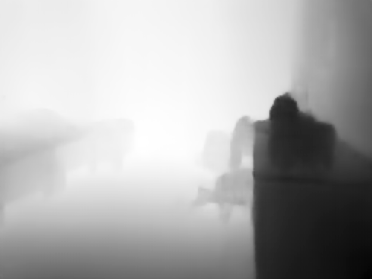

**Depth map**

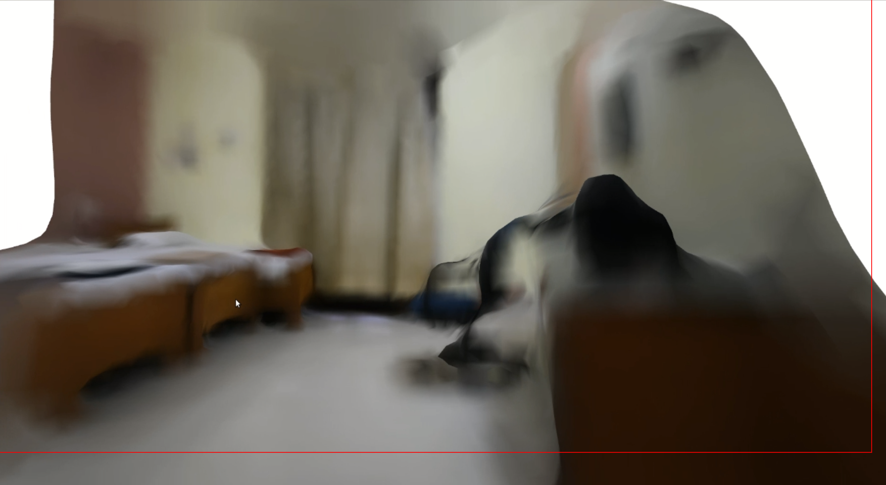

**3D Scene reconstruction**

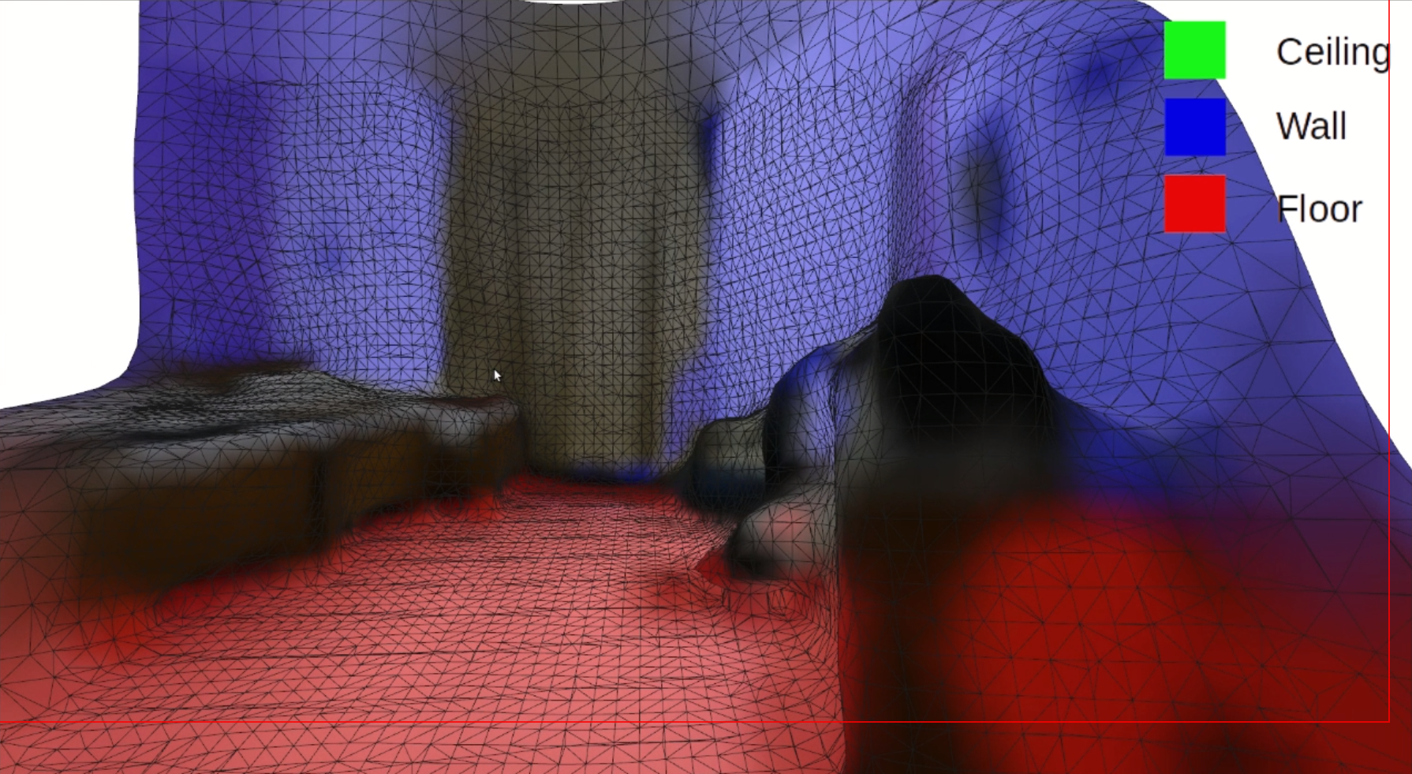

**Semantic 3D wireframe**

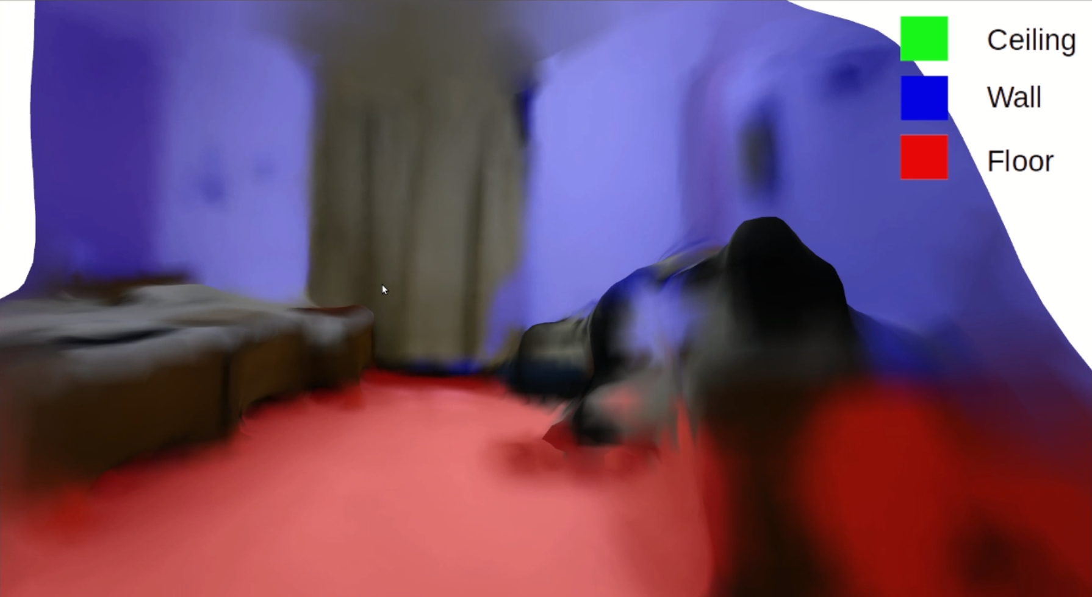

**3D Semantic rendered Scene**

1. **References**

[1] C. B. Choy, D. Xu, J. Gwak, K. Chen, and S. Savarese, “3d-r2n2: A unified approach for single and multi-view 3d object reconstruction,” in *European conference on computer vision*. Springer, 2016, pp. 628–644.

[2] U. Gu¨du¨kbay and F. Durupınar, “Three-dimensional scene representations: Modeling, animation, and rendering techniques,” in *Three-Dimensional Television*. Springer, 2008, pp. 165– 200.

[3] Zeng, W., Karaoglu, S., & Gevers, T. (2020). Pano2Scene: 3D Indoor Semantic Scene Reconstruction from a Single Indoor Panorama Image. In *BMVC*.

[4] X. Han, H. Laga, and M. Bennamoun, “Image-based 3D object reconstruction: State-of-theart and trends in the deep learning era,” *IEEE transactions on pattern analysis and machine intelligence*, 2019.

[5] C. Russell, R. Yu, and L. Agapito, “Video pop-up: Monocular 3D reconstruction of dynamic scenes,” in *European conference on computer vision*. Springer, 2014, pp. 583–598.

[6] D. Shin, Z. Ren, E. B. Sudderth, and C. C. Fowlkes, “3D scene reconstruction with multilayer depth and epipolar transformers,” in *Proceedings of the IEEE International Conference on Computer Vision*, 2019, pp. 2172–2182.

[7] C. Wang, S. Lucey, F. Perazzi, and O. Wang, “Web stereo video supervision for depth prediction from dynamic scenes,” in *2019 International Conference on 3D Vision (3DV)*. IEEE, 2019, pp. 348– 357.

[8] N. Xue, T. Wu, S. Bai, F. Wang, G.-S. Xia, L. Zhang, and P. H. Torr, “Holistically-attracted wireframe parsing,” in *Proceedings of the IEEE/CVF Conference on Computer Vision and Pattern Recognition*, 2020, pp. 2788–2797.

[9] Y. Yao, N. Schertler, E. Rosales, H. Rhodin, L. Sigal, and A. Sheffer, “Front2back: Single view 3d shape reconstruction via front to back prediction,” in *Proceedings of the IEEE/CVF Conference on Computer Vision and Pattern Recognition*, 2020, pp. 531–540.

[10] Chuhang Zou, Alex Colburn, Qi Shan, and Derek Hoiem. Layoutnet: Reconstructing the 3d room layout from a single rgb image. In Proceedings of the IEEE Conference on Computer Vision and Pattern Recognition (CVPR), pages 2051–2059, 2018.

[11] Ummenhofer, B., Zhou, H., Uhrig, J., Mayer, N., Ilg, E., Dosovitskiy, A., & Brox, T. (2017). Demon: Depth and motion network for learning monocular stereo. In *Proceedings of the IEEE Conference on Computer Vision and Pattern Recognition* (pp. 5038-5047). Code at:

<https://github.com/lmb-freiburg/demon>

Aug, 2022