**Auto-estimation of homography over a planar patch, from a single view**

Computer Vision (CS6350)

TPA - 14

**1. Problem statement:**

Homography estimation is an important step in many computer vision problems. A homography models the global geometric transformation between two images. Typically, given two views of a scene consisting of a planar patch, one may use DLT or its variant to compute homography matrix, **H**

where **I' = H.I**

In this assignment, we look at the inverse situation to solve an ill-posed problem, where given an inclined texture **I’** we try to estimate both homography matrix, **H** andorthogonal image, **I**.

The task is to estimate **H** of a planar patch but only from a single view image (**I'**) consisting of an inclined planar texture surface. Additionally, we need to reconstruct and display the input image **I** as that would have been visible before and after transformation.

A few assumptions can be made - e.g.  **I** is the orthogonal view of the planar patch.

For example: One can assume to transform the upright planar patch by H, by a perspective transformation of a camera placed exactly in front of the input image (as shown below).

**2. Input Image:**

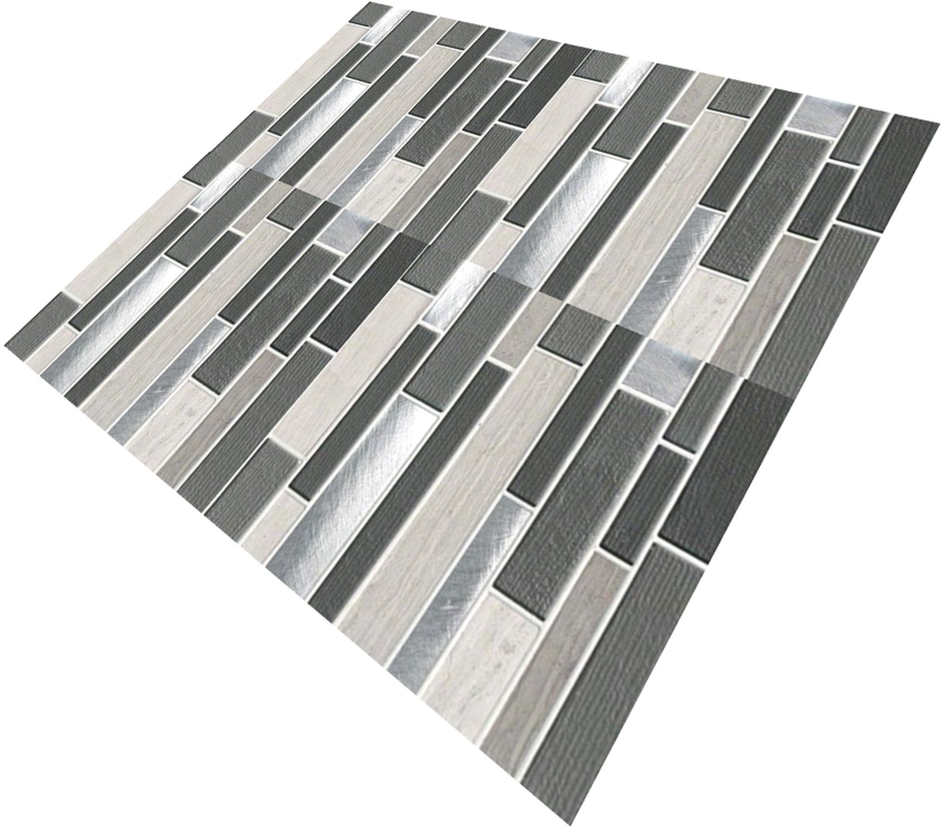

**3.Outputs:**

1. Orthogonal Image **(I)**



1. Homography matrix **(H**)

Note: You may create as many samples of **I’** (inputs) as you like, using H = KRK’ and other texture samples.

**5.References:**

[1]. Andrejs Rudzitis, Margarita A. Zaeva, Alternative Inverse Perspective Mapping Homography Matrix Computation for ADAS Systems Using Camera Intrinsic and Extrinsic Calibration Parameters,Procedia Computer Science, Volume 190, 2021

[2]. Le, Hoang, et al. "Deep homography estimation for dynamic scenes." *Proceedings of the IEEE/CVF Conference on Computer Vision and Pattern Recognition*. 2020.

[3].Zhang, Jirong, et al. "Content-aware unsupervised deep homography estimation." *European Conference on Computer Vision*. Springer, Cham, 2020..

[4]. DeTone, Daniel, Tomasz Malisiewicz, and Andrew Rabinovich. "Deep image homography estimation." arXiv preprint arXiv:1606.03798 (2016).

[5]. Nie, Lang, et al. "Depth-Aware Multi-Grid Deep Homography Estimation with Contextual Correlation." *arXiv preprint arXiv:2107.02524* (2021).

[6]. Baker, Simon, Ankur Datta, and Takeo Kanade. "Parameterizing homographies." *Technical Report CMU-RI-TR-06-11*. 2006.

[7]. <https://forum.opencv.org/t/warpperspective-but-inverse-homography/5547>

[8]. https://stackoverflow.com/questions/42396860/inverse-homography

Aug. 2022.