**Video Analytics: Prediction, text paraphrasing or any new/novel ideas/tasks yet unheard of**

Computer Vision (CS6350)

**TPA-4**

1. **Problem Statement**

This is an open-ended project where students are expected to provide an innovative solution to new or very recent problem domains which you can imagine and formulate on your own. Examples of such problems are video prediction, text paraphrasing to describe a video, and identification of peculiarities/anomalies in the video shots.

1. **Input & Output**

The input and output depend on the problem and solution you formulate.

For Example: Video Prediction Problem

**Sample Input-Output [2] :**

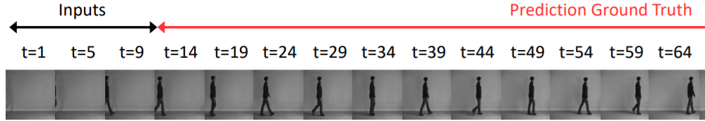

**Caution/Warning**: If any of these cases are technically trivial, you may score less than satis-factory marks. So go ahead and innovate on your own. Please inform the Course Instructor and Teaching Assistants about the problem and take prior permission to work on this problem.

1. **References**
   1. Science fiction movies, or any equivalent web/TV series.
   2. Lee, Sangmin, et al. "Video Prediction Recalling Long-term Motion Context via Memory Alignment Learning." Proceedings of the IEEE/CVF Conference on Computer Vision and Pattern Recognition. 2021.
   3. Bhattacharjee, P., & Das, S. (2017). Temporal coherency based criteria for predicting video frames using deep multi-stage generative adversarial networks. In Advances in Neural Information Processing Systems (pp. 4268-4277).
   4. Bhattacharjee, Prateep, and Sukhendu Das. "Directional attention based video frame prediction using graph convolutional networks." 2019 International Joint Conference on Neural Networks (IJCNN). IEEE, 2019.
   5. Wang, Y., Jiang, L., Yang, M. H., Li, L. J., Long, M., & Fei-Fei, L. (2018). Eidetic 3D LSTM: A Model for Video Prediction and Beyond.

Aug, 2022