**Segmentation of Panorama**

Computer Vision (CS6350)

**TPA - 6**

1. **Problem Statement**

Segmentation is the process of partitioning an image into multiple segments. Semantic segmentation refers to assigning a class label to each pixel. It is an essential tool in robotics. Panorama images give a better understanding of a scene due to its wider field of view (FoV). It has been shown that panoramic images provide better performance than a regular image. The task is to generate semantically segmented panorama using RGB panorama.

1. **Input**

Panorama image. Training and testing samples may not overlap.

1. **Output**

* Segmentation predictions; each output pixel with a color-coded class label.
* Quantitative evaluation metric (E.g. IoU metric)
* Demo to run on a given panorama (Demo should run live on Desktop/Laptop with GPU (prefer-able for extra credit)).

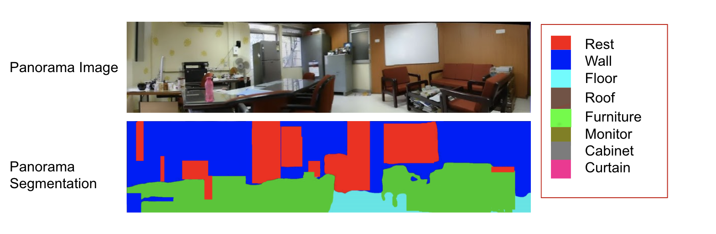

1. **Dataset**

* Cityscapes [3]: This dataset consists of 5k street scene images, which have all been taken in German cities. There are annotations for 8 things classes and 11 stuff classes. [Link](https://www.cityscapes-dataset.com)
* Mapillary Vistas [4]: Mapillary Vistas is a more challenging dataset, consisting of 25k street scene images. The images have annotations for 37 things classes and 28 stuff classes.
* PASS dataset: There are 400 panoramas with annotations. In total 1050 panoramas are present. [Link](https://drive.google.com/file/d/1A_P2u5HUbrHZnKJYAOL2f7JLxxj69LqB/view?usp=sharing)

**Note**: Either two of these datasets can be used for the purpose.

1. **References**
2. Kailun, Xinxin, et al. PASS: Panoramic Annular Semantic Segmentation Proceedings of the IEEE transactions on intelligent transportation systems, September 2019.
3. Kailun Yang, Xinxin Hu, et al. DS-PASS: Detail-Sensitive Panoramic Annular Semantic Segmentation through SwaftNet for Surrounding Sensing. Proceedings of the IEEE Conference onComputer Vision and Pattern Recognition. 2019.
4. Cordts, Marius, et al. "The cityscapes dataset for semantic urban scene understanding." Proceedings of the IEEE conference on Computer Vision and Pattern Recognition. 2016.
5. Neuhold, Gerhard, et al. "The mapillary vistas dataset for semantic understanding of street scenes." Proceedings of the IEEE International Conference on Computer Vision. 2017.
6. Yuanyou Xu, Kaiwei Wang, et al. "Semantic Segmentation of Panoramic Images Using a Synthetic Dataset." (2019).

Aug, 2022