**Joint Image Deblurring and Super-Resolution**

Computer Vision (CS6350)

**TPA-7**

1. **Problem Statement**

The problem introduces the super-resolution task with the presence of motion blur.

Given a natural image with severe blur, the task is to generate a clear high-resolution Image.

1. **Input**

A blurred image

1. **Expected Output**

* Clear High-resolution Image.
* Quantitative Evaluation metric PSNR and SSIM.
* Demo to run on a given image.

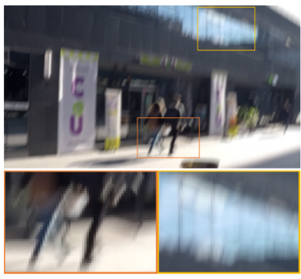 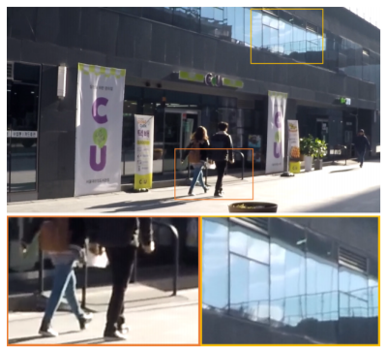

Input: Blurry, Low-resolution Image Output: High-Resolution Image

1. **Dataset**

* [GOPRO](https://seungjunnah.github.io/Datasets/gopro) [5]: The dataset contains 2103 blurry and sharp HR image pairs.

1. **References**
   1. Zhang, Xinyi, et al. "Gated Fusion Network for Joint Image Deblurring and Super-resolution", in British Machine Vision Conference (BMVC), 2018.
   2. Zhang, Xinyi, et al. "A Deep Encoder-Decoder Networks for Joint Deblurring and Super-resolution", In IEEE International Conference on Acoustics, Speech and Signal Processing (ICASSP), 2018.
   3. Xu, Xiangyu, et al. "Learning to super-resolve blurry face and text images", in Proceedings of the IEEE International Conference on Computer Vision (ICCV), 2017.
   4. Albluwi, Fatma, Vladimir A. Krylov, and Rozenn Dahyot. "Image Deblurring and Super-resolution using Deep Convolutional Neural Networks" in IEEE 28th International Workshop on Machine Learning for Signal Processing (MLSP), 2018
   5. Nah, Seungjun, Tae Hyun Kim, and Kyoung Mu Lee. "Deep multi-scale convolutional neural network for dynamic scene deblurring", in Proceedings of the IEEE Conference on Computer Vision and Pattern Recognition (CVPR), 2017

Aug, 2022