**Detection of overlapping objects**

Computer Vision (CS6350)

TPA - 8

1. **Problem Statement**

The task is to detect overlapping objects from 2D images. For example, a 2D image containing a bunch of coins, vegetables, etc. Although a plethora of algorithms exists, accurate detection is challenging because of object-to-object variability, object shape irregularities, presence of cluttered & overlapping objects, image noise and contrast which requires problem-specific tailoring of algorithms. The goal of this project is to develop an efficient algorithm to accurately detect coins in an image containing coins and detect vegetables in an image containing vegetables.

1. **Input**

* 2D image consist of Coins on a table
* 2D image consist of Vegetables

.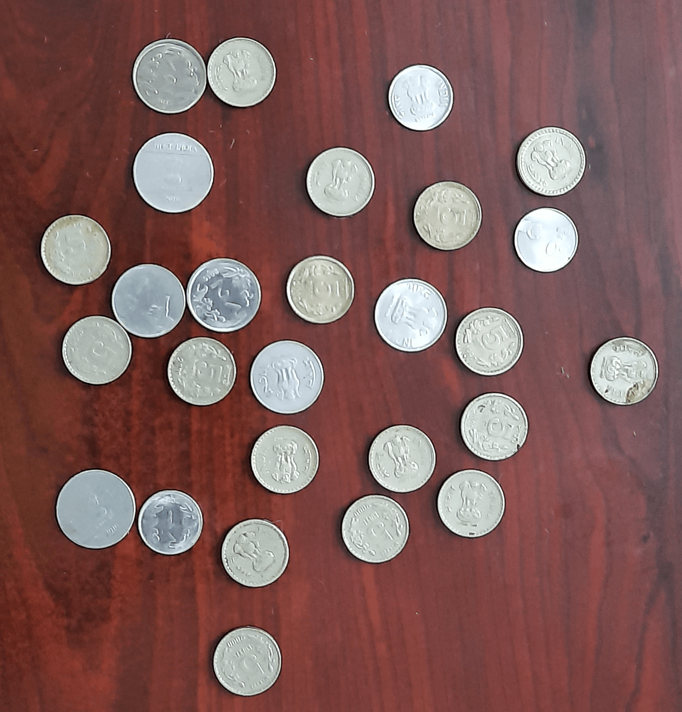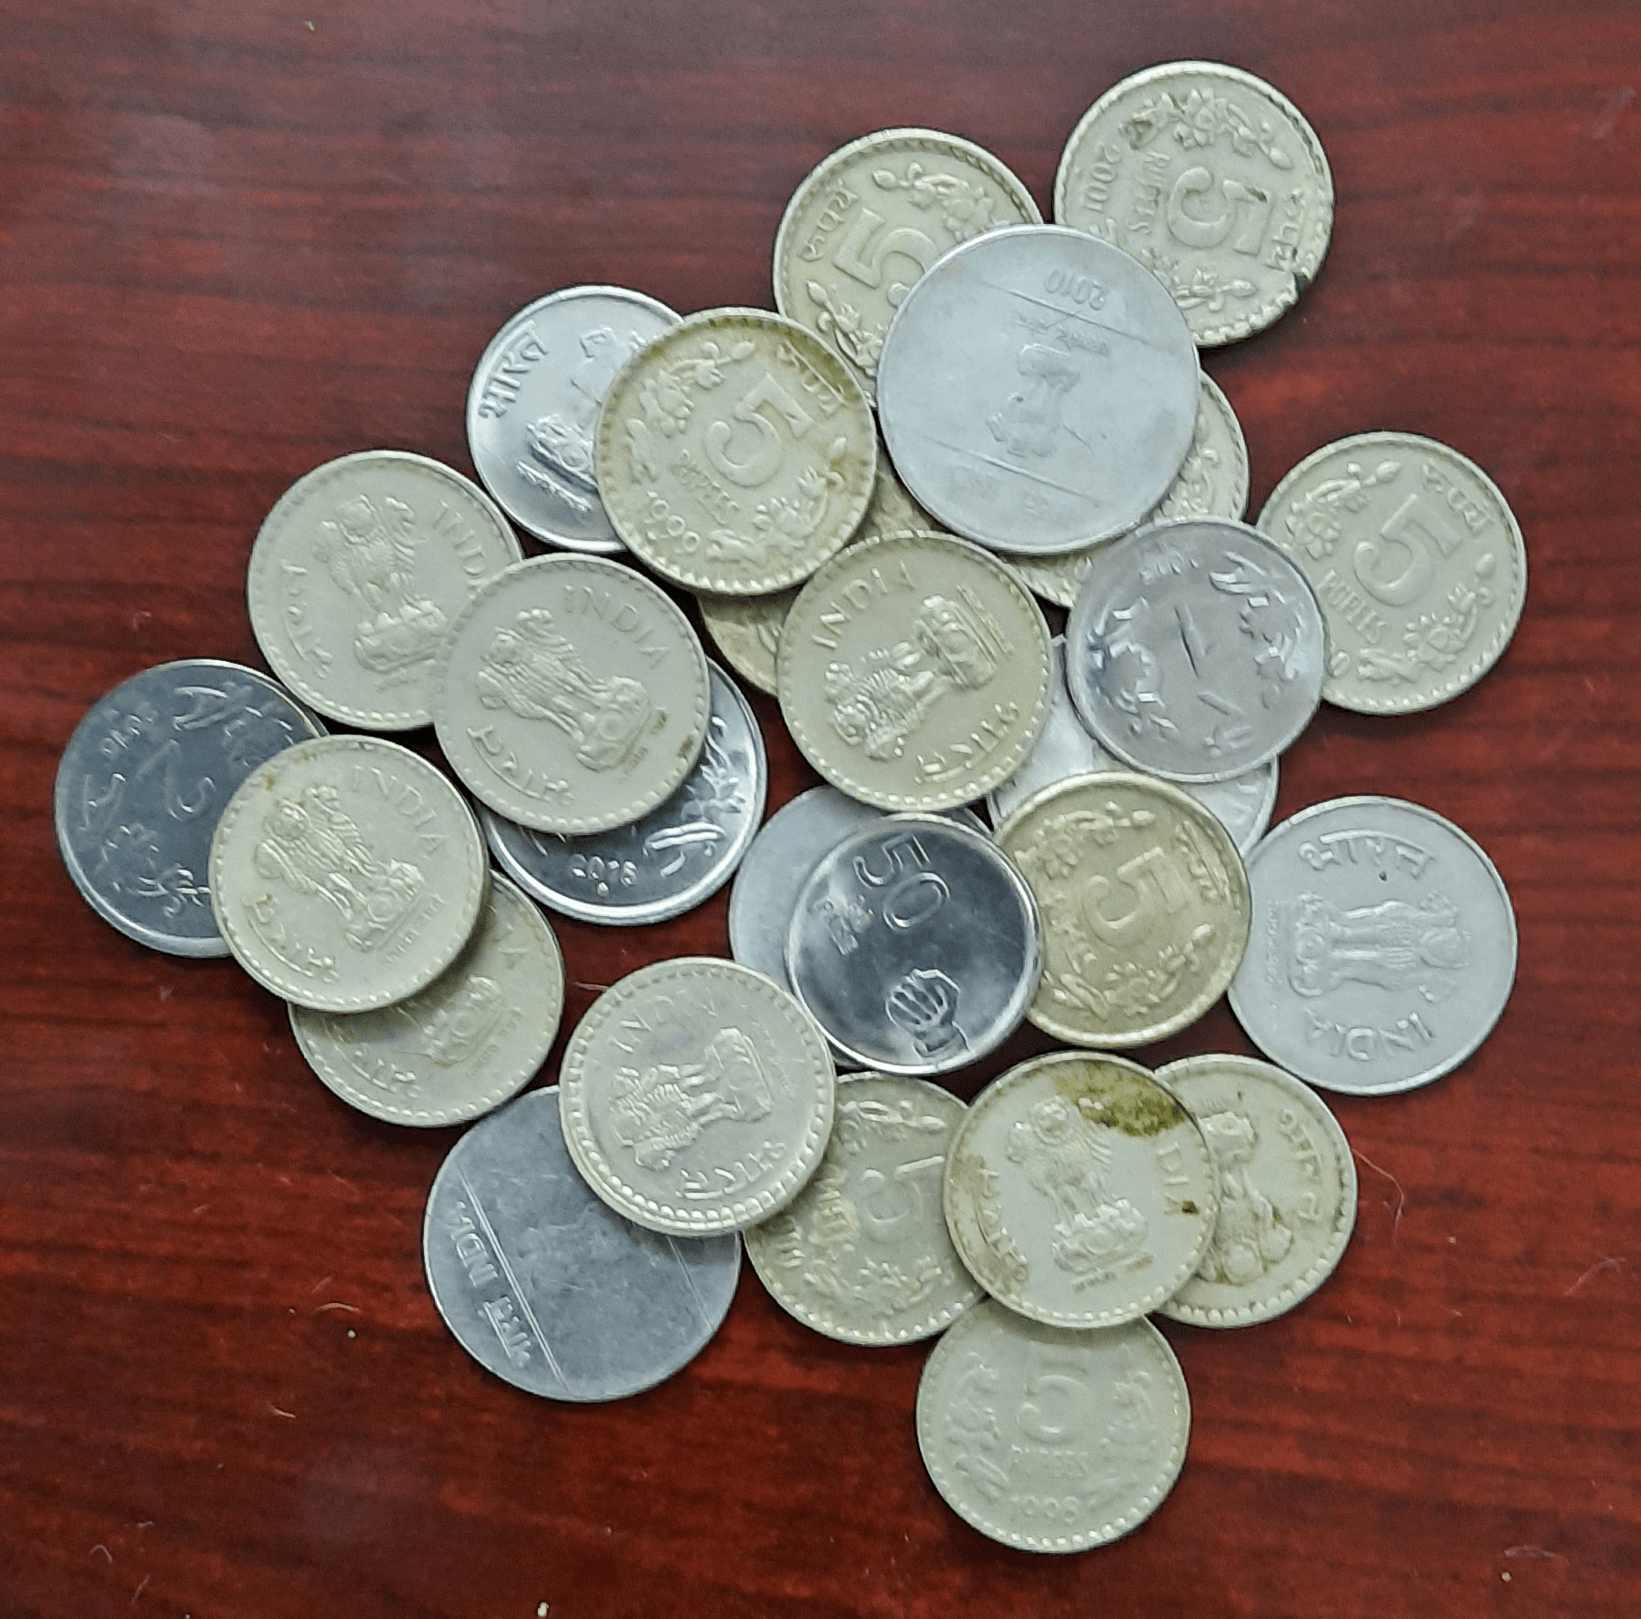

Fig 1

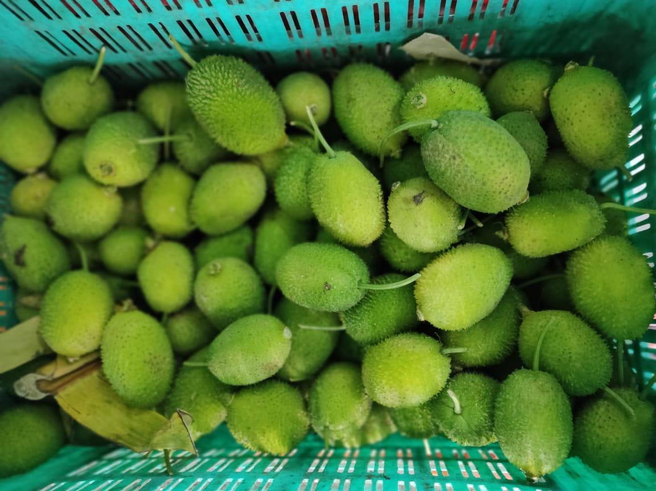

Fig. 2

**3. Expected Output**

* **Qualitative Results:** Location of the coin/vegetable in the image.
* **Quantitative Results:** Precision-Recall values for each test image provided.

**4.Dataset**

* Coin Dataset
* Fruit Dataset

5.**References**

1. Zafari, S., Eerola, T., Sampo, J., K¨alvi¨ainen, H., Haario, H. (2015). Segmentation of overlap ping elliptical objects in silhouette images. IEEE Transactions on Image Processing, 24(12), 5942-5952.

2. Wang, P., Wang, L., Li, Y., Song, Q., Lv, S., Hu, X. (2019). Automatic cell nuclei seg mentation and classification of cervical Pap smear images. Biomedical Signal Processing and Control, 48, 93-103.

3. Xing, F., Yang, L. (2016). Robust nucleus/cell detection and segmentation in digital pathol ogy and microscopy images: a comprehensive review. IEEE reviews in biomedical engineering, 9, 234-263.

4. Xie, W., Noble, J. A., & Zisserman, A. (2018). Microscopy cell counting and detection with fully convolutional regression networks. Computer methods in biomechanics and biomedical engineering: Imaging Visualization, 6(3), 283-292.

5. Xie, Y., Xing, F., Shi, X., Kong, X., Su, H., & Yang, L. (2018). Efficient and robust cell detection: A structured regression approach. Medical image analysis, 44, 245-254.

6. Redmon, J., & Farhadi, A. (2018). Yolov3: An incremental improvement. arXiv preprint arXiv:1804.02767.

7. Das, S., Jayakumar, J., Banerjee, S., Ramaswamy, J., Vangala, V., Ram, K., & Mitra, P. (2019). High precision automated detection of labeled nuclei in Gigapixel resolution image data of Mouse Brain. BioRxiv, 252247.

Aug, 2022