**Learn image auto-correction (brush restoration) and auto-enhancement from few training samples**

Computer Vision (CS6350)

**TPA-9**

1. **Problem Statement**

The aim is not to restore old photos (although that can be a sub-task or ancillary), but create photo-realistic effects as created by manual professionals working in a studio, from old/archived photos.

1. **Input:**

Old/archived images (perhaps B/W)

1. **Output:**

Photo-finished outputs, with manually tuned color and contrast enhancements done (as typically expected in a professional & commercial photo-studio).

Assume a small number of training samples, as given below. You may use any auxiliary dataset for training, but note that:

1. Simple Restoration tasks (anti-blur, scratch, spots & noise removal etc. are not intended here;
2. You cannot blame a dataset you choose (your responsibility) if the results are not along expected lines, as in sample below.

**5. References**

<https://citeseerx.ist.psu.edu/viewdoc/download?doi=10.1.1.259.1365&rep=rep1&type=pdf>

<https://i.cs.hku.hk/~yzyu/publication/DNNphoto-tog2016.pdf>, <https://arxiv.org/abs/1412.7725>

<https://paperswithcode.com/task/image-restoration>

<https://towardsdatascience.com/how-to-perform-image-restoration-absolutely-dataset-free-d08da1a1e96d>

<https://www.analyticsvidhya.com/blog/2020/02/what-is-autoencoder-enhance-image-resolution/>

<https://www.researchgate.net/publication/279036692_Computer-assisted_analysis_of_painting_brushstrokes_digital_image_processing_for_unsupervised_extraction_of_visible_features_from_van_Gogh%27s_works>

Few Samples.

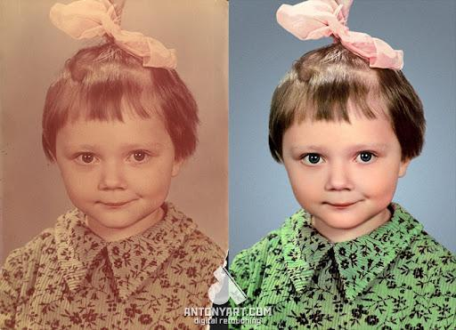

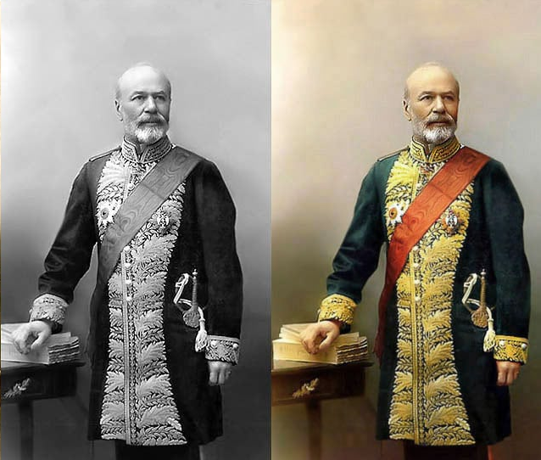

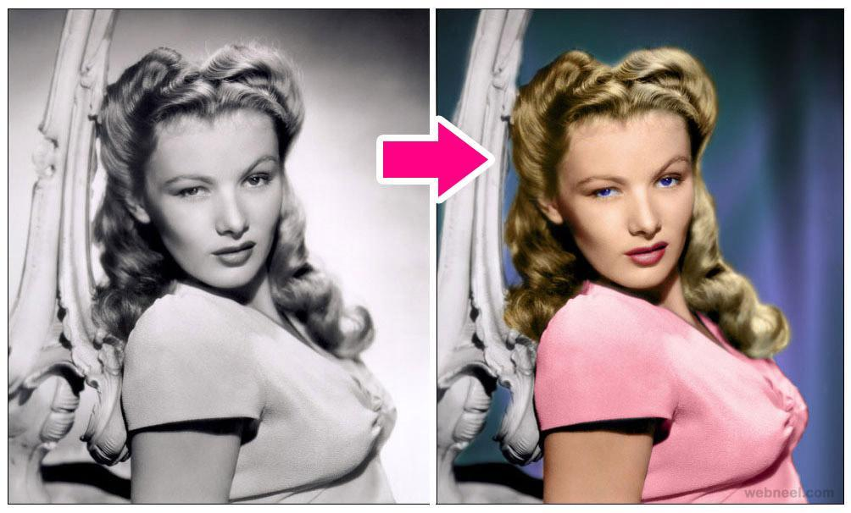

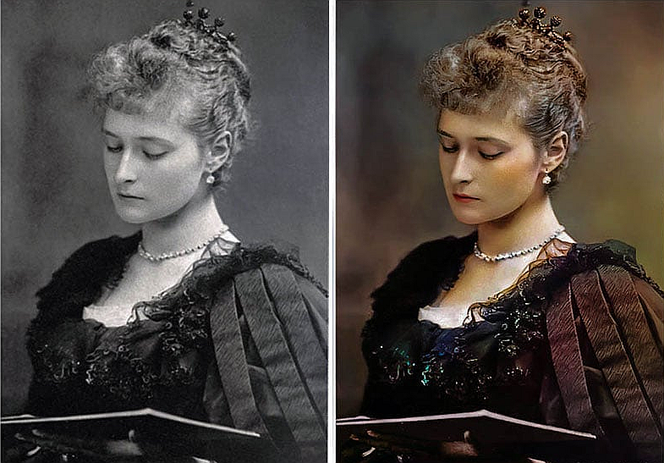

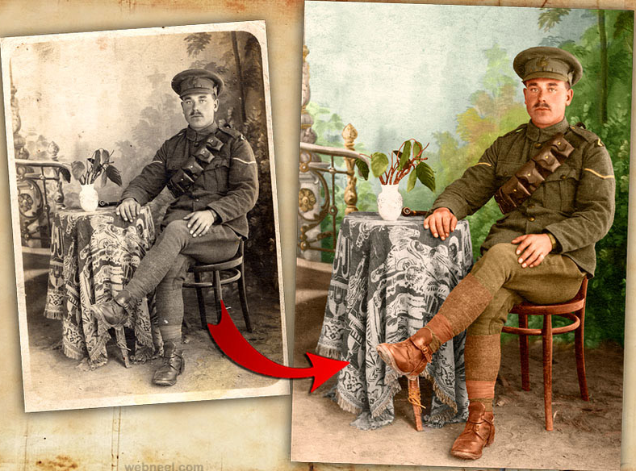

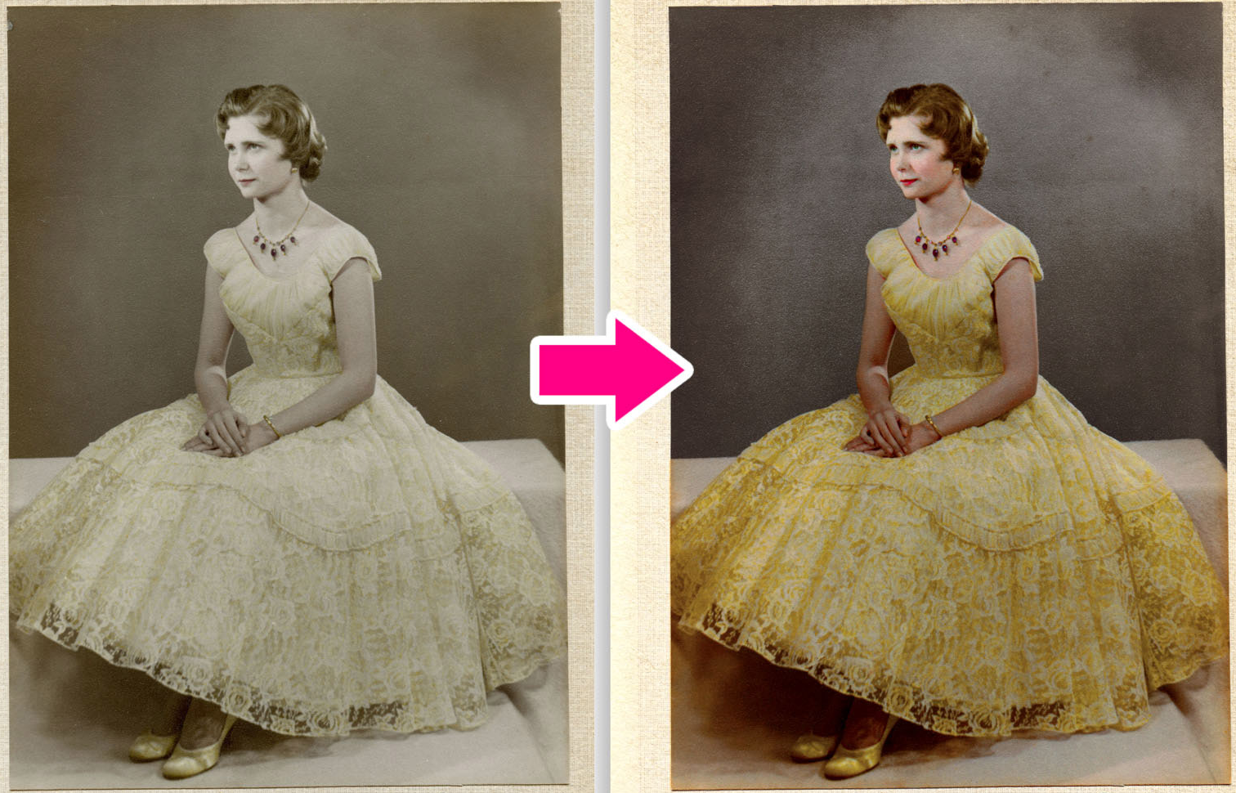

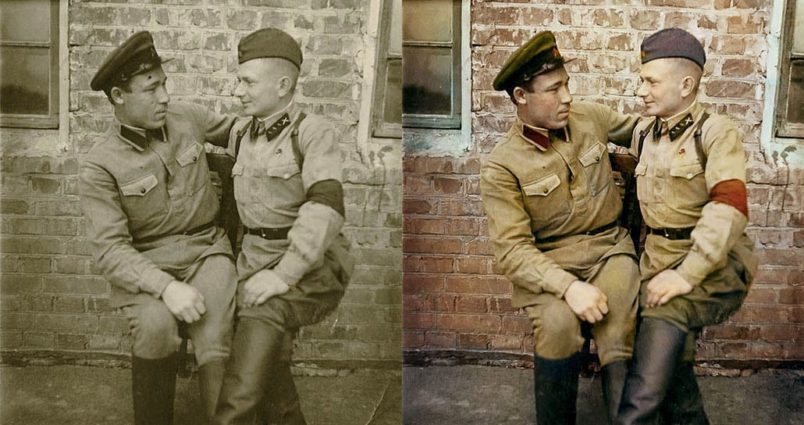

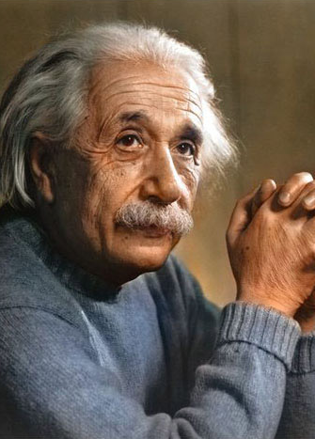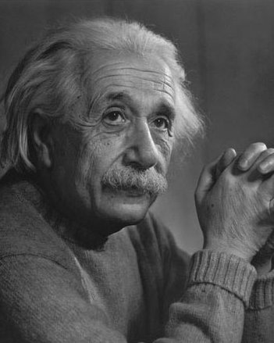

Aug, 2022