Outline of an APPROX-TSP-TOUR
First, compute a MST (minimum spanning tree) whose weight is a lower bound on the length of an optimal TSP tour. Then, use MST to build a tour whose cost is no more than twice that of MST's weight as long as the cost function satisfies triangle inequality.

Operation of APPROX-TSP-TOUR
Let root r be a (starting point) in following given set of points (graph). Cost is the Euclidean distance between the points
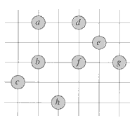
Construct MST from root a using MST-PRIM (G, c, r).
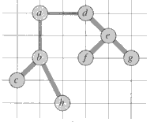
List vertices visited in preorder walk. L = {a, b, c, h, d, e, f, g}
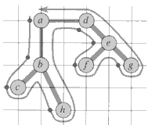
Return Hamiltonian cycle.
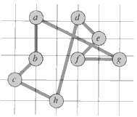
Optimal TSP tour for a given problem (graph) would be
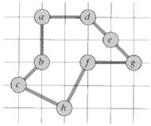
which is about 23% shorter.

